PRESS RELEASE JDN99

J D NEUHAUS HOISTS HANDLE OFFSHORE SEAWATER PUMPS

When the seawater pump on an offshore rig needed replacing, an air hoist supplied by materials handling specialists J D Neuhaus, was on hand to provide safe lifting of the components. Seawater pumps are an integral part of the working environment within oil and gas offshore structures. Seawater itself is utilised for general cooling of on-site production activities, while also providing a major safety dousing factor in the event of fire or leakage occurring in the hazardous and potentially explosive offshore atmospheric conditions.

The maintenance, repair or even total replacement of the associated pumps and pipework in such locations is undertaken by Gerritsen On- & Offshore Services BV, with work recently carried out at a rig located in the southern North Sea. A four man team undertook the dismantling of one pump and pipework assembly out of the three similar installations in the pump area. To handle the lifting and temporary storage of the components involved, an approximate 20 metre lift from sea level to an upper storage area was required. To undertake this task an air operated hoist model EH20 as manufactured by the J D Neuhaus company was utilised. This product offered a SWL capacity of 20 tonnes, providing intrinsically safe performance within such hazardous environments with appropriate Ex safety ratings for such work. It was provided with a chain drop lift capacity of 12 metres, and included a similar length umbilical for the hoist hand controller with the operator located at the lower deck. The EH model JDN hoist was mounted on an overhead rail which provided the necessary lateral movements to facilitate individual load laydowns at a temporary storage area prior to undertaking the reassembly task.

Continued ……
The pump riser pipework comprised a total of eight x 3.5 metre long x 16 inch diameter pipes, which were disconnected to provide two connected pipes per lift. The pump located at the bottom of the pipework was itself approximately 8 metres in length and weighed some 9250kg.

The EH20 is part of the JDN monorail air hoist range designed for handling heavy loads while operating within confined spaces. A total of 11 models are available, with lift capacities ranging from 10 up to a full 100 tonnes. These hoists are insensitive to humidity and dust, while operating within a temperature range of -20°C up to 70°C. They incorporate a low-headroom compact design ideally suited to working in hazardous areas. They feature low air consumption with an instant starting vane motor requiring low maintenance. They also incorporate a fail-safe disc brake to hold loads safely in the event of interruption to the power air supply. Anti-climb and anti-drop devices are supplied as standard, together with lateral guiding plates. Increased spark and overload protection, rack and pinion drive, two-speed trolley travel control and filter silencers are also available as accessories. The pendant controllers incorporate an emergency shut-off valve and are designed for multi-function use. This includes the operation of twin hoists where they can be used in tandem or parallel configurations while still providing precise load control together with twin speed trolley travel movements.

Gerritsen On- & Offshore Services BV are the authorised Dutch Sole Importer of JDN products.

Further information is available on request to:
J D Neuhaus GmbH & Co. KG, 58449, Witten-Heven, Germany
Telephone: +49 2302 208-219 Fax: +49 2302 208-286
e-mail: info@jdngroup.com www.jdngroup.com

Worldwide contact details for J D Neuhaus can be seen at the end of this press release.

facebook.com/jdneuhaus www.jdngroup.com/plus

(approximately 600 words
including photographic annotations)

Continued ……
General Information

Supplier: J. D. Neuhaus GmbH & Co. KG

Press Release No: JDN99

Press or publishing inquiries to: Steve Lloyd
Enterprise Marketing Services Ltd
The Coach House, 1 Dunstall Road, Barton under Needwood,
Burton on Trent, Staffordshire, DE13 8AX, UK
Tel: +44 (0) 1283 713185
Fax: +44 (0) 1283 716172
e-mail: info@enterprise-marketing.co.uk

Reader response inquiries to: Mr Manfred Müller of J D Neuhaus GmbH & Co. KG

Downloads: The press release text (MS Word and PDF format) and images are
available for download at:

www.enterprise-marketing.co.uk/jdn/jdn99.html

Our Reference: JDN99/15/04/V4

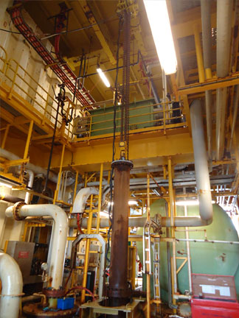
Lifting a double pipeline assembly, forming part of a seawater lift-pump unit in operation on a southern North Sea rig, utilising a J D Neuhaus monorail air operated hoist type EH20.
Download high resolution 300dpi image
Download low resolution 72dpi image

Continued ……
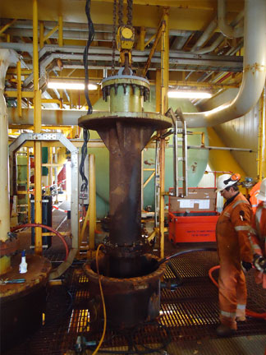
The start of dismantling seawater pumping equipment on an offshore rig utilising a J D Neuhaus air operated hoist.
Download high resolution 300dpi image
Download low resolution 72dpi image

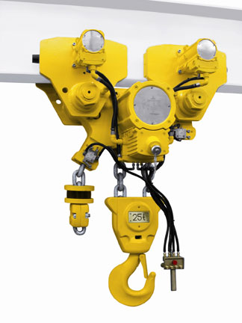
A typical JDN air operated monorail hoist designed for operations in confined spaces in offshore locations.
Download high resolution 300dpi image
Download low resolution 72dpi image
Continued ……
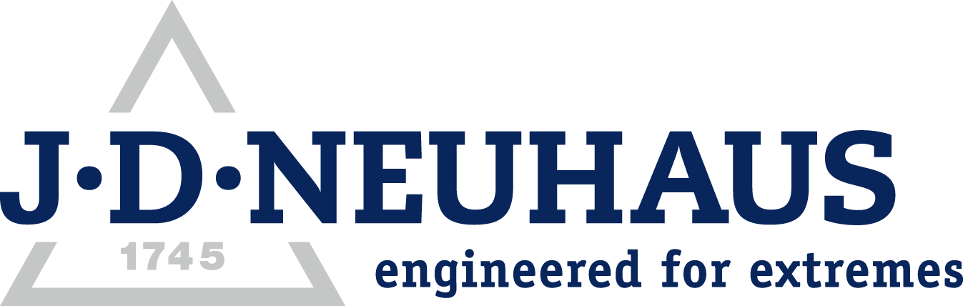
Company information

J D Neuhaus are a privately-owned company, founded in 1745, and for over 265 years they have been using their expertise and experience to manufacture the highest quality hoists and cranes.

Their products offer solutions to almost every material handling problem irrespective of the driving medium: from air and hydraulic hoists up to complete crane installations with explosion proofness.

JDN products are used in a wide variety of industries including:
Airplane Yards; Atomic/Coal Power Stations; Big Bag Handling; Cement Industry; Chemical Industry;
Crane Manufacturers; Dairies; Food Industry; Foundries; Galvanisation; Glass/Ceramics; Large Kitchens;
Leather Plants; Locks; Machine and Plant Construction; Mining; Motor Car Industry; Offshore/Onshore;
Oil Storage; Over/Underground Construction; Paints and Varnish; Painting and Coating Installations;
Paper Industry; Pharmaceutical Industry; Printing Industry; Pyrotechnics Industries; Refineries; Sawmills; Shipbuilding and Shiprepair Yards; Ships; Space Technique; Spray Booths; Steel Works; Surface Technique;
Tank Cleaning Devices; Textile Industry; Tunnel; Tyre Manufacturers; Vacuum Technique

Contact J D Neuhaus

J D Neuhaus are represented in more than 90 countries and over 70 branches Worldwide.

Germany
J D Neuhaus GmbH & Co. KG, 58449, Witten-Heven, Germany
Tel: +49 2302 208-219 Fax: +49 2302 208-286
e-mail: info@jdngroup.com www.jdngroup.com

France
J D Neuhaus S.A.R.L., 24, rue du Président Krüger, 69008, Lyon, France
Tel: +33 4 3790-1745 Fax: +33 4 3790-1746
e-mail: info@jdneuhaus.fr www.jdngroup.com

Great Britain
J D Neuhaus Ltd, Unit 6 Kirkton Avenue, Pitmedden Road Industrial Estate, Dyce, Aberdeen, AB21 0BF, UK
Tel: +44 1224 722751 Fax: +44 1224 729895
e-mail: info@jdneuhaus.co.uk www.jdngroup.com

Singapore
J.D. Neuhaus Pte. Ltd, 21 Toh Guan Road East, #09-02 Toh Guan Centre, 608609, Singapore
Tel: +65 62758911 Fax: +65 62758922
e-mail: info@jdn.com.sg www.jdngroup.com

USA
J.D. Neuhaus L.P., 9 Loveton Circle, MD 21152 Sparks, USA
Tel: +1-410 472-0500 Fax: +1-410 472-2202
e-mail: info@jdneuhaus.com www.jdngroup.com

